# Hans Alberto Franke

## Date: 24/11/2020

## Last screen shot from the tutorial session:

1. I use background with googlemaps, just to bring context.
2. Dot Red lines = routes from Fire Station Code = 22565 (hospital symbol :P)
3. Dot **Black** lines = routes from Fire Station Code = 19354 (hospital symbol)
4. I build every query (one fire station to all destinations) just to visualize the possible routes and options, then filter the closets ones.

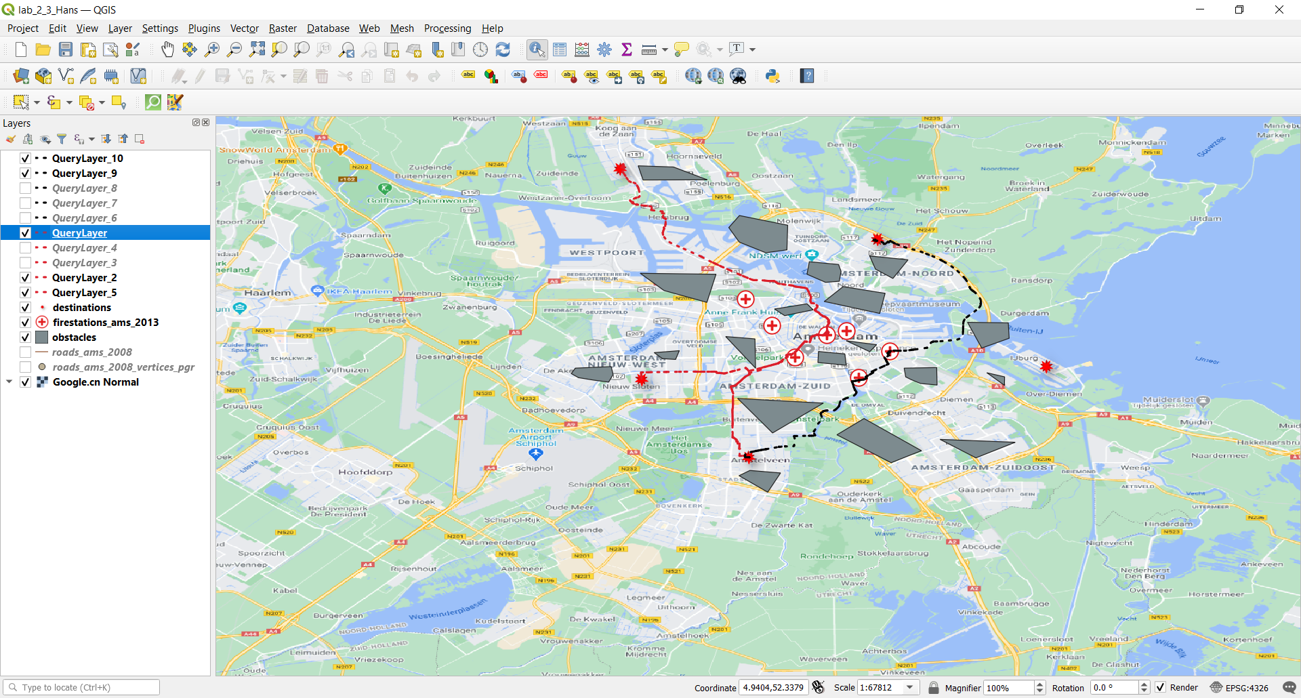

Assignment:

routing for an ambulance in the presence of obstacles In this assignment, you do a similar kind of analysis and navigate an ambulance from its station in Amsterdam to the same 5 destinations (as used in this Lab). For your convenience, you may use the dataset ambulance stations (ambulanceposten) we provided in the zipped data file or download the dataset ambulance stations(ambulanceposten) of the Netherlands via the following link (using ArcGIS to export the data) https://shorturl.at/qvzF4. To help select an ambulance station in Amsterdam, you may visualize the dataset by importing the shp data into QGIS and use OBJECTID to locate an ambulance station in Amsterdam. You can reuse the AMS street network dataset and adapt your codes if necessary. We assume that the status of the street network will not change significantly in the next 30 mins.

So you can reuse the dataset of the obstacles as well. In your submitted document, please include the following:

## A screenshot of the used datasets (Amsterdam area), and please indicate which ambulance station in the city of Amsterdam is selected (ID, coordinate, address, etc) ;

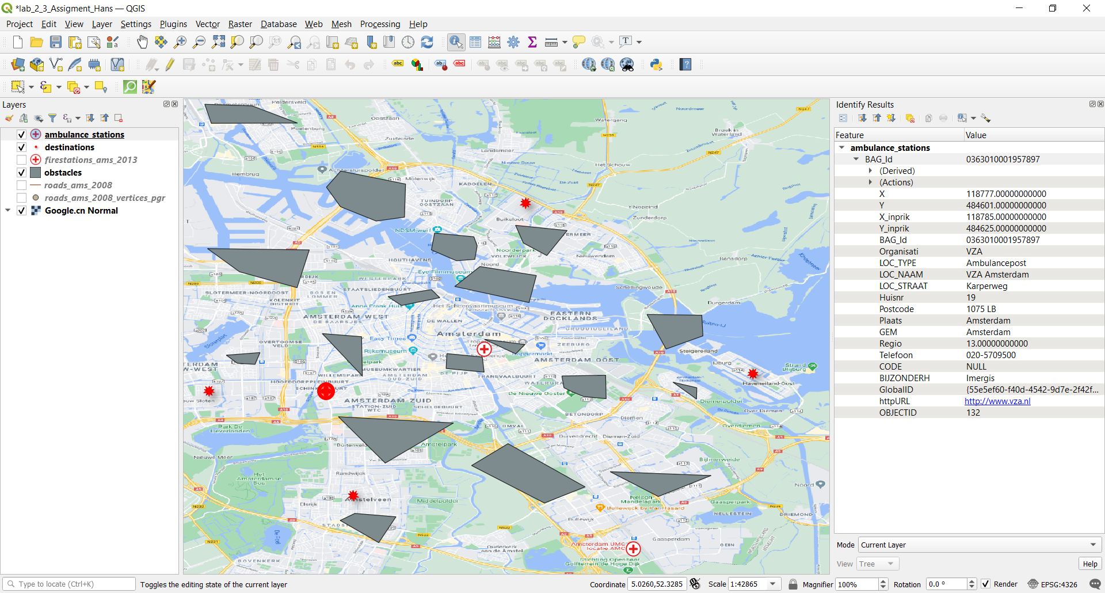

Code:

*--select best node entry for ambulance ID: 14529*

*SELECT roads_ams_2008_vertices_pgr.id FROM roads_ams_2008_vertices_pgr,*

*ambulance_stations where ambulance_stations.OBJECTID=132 ORDER BY*

*ST_Distance(ST_Transform(ST_SetSRID(ambulance_stations.geom, 4326),*

*28992), ST_Transform(roads_ams_2008_vertices_pgr.the_geom, 28992)) ASC*

*LIMIT 1;*

## Screenshots of the safe routes from the selected ambulance station to the five given destinations (avoiding the obstacles).

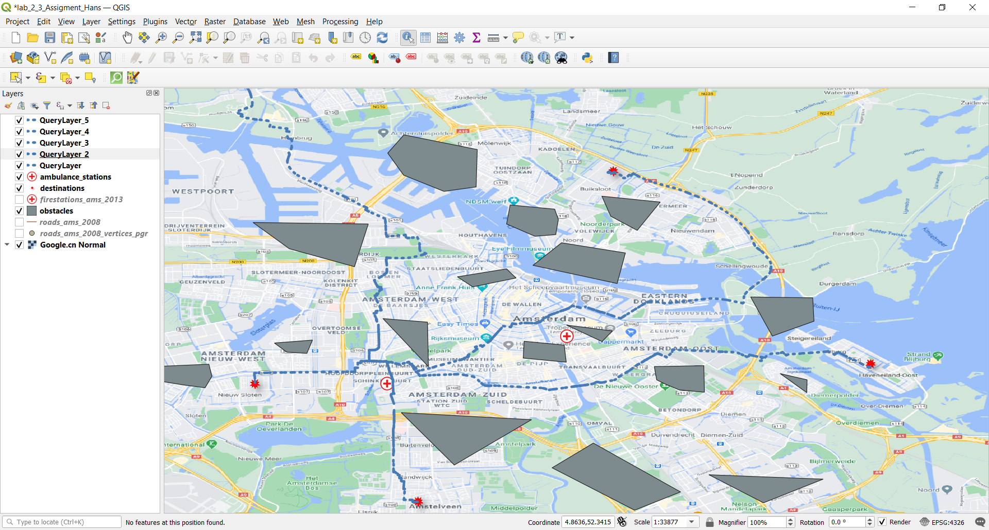

Note, the 5 station is not in the map, I chose now zoom out to made a clear visualization.

Hospital symbol = ambulances

Explosion symbol = events

## A table with the details of the safe routes (e.g., travel distance).

A table consist of origin x destination: So we have a cod id of origin (ambulance) and many code destinations (fires places..)

Using code to see agg.costs = distance travelled:

*SELECT * FROM pgr_dijkstra('*

*SELECT gid AS id,*

*source,*

*target,*

*cost,*

*reverse_cost*

*FROM roads_ams_2008',*

*14259, 32485, false);*

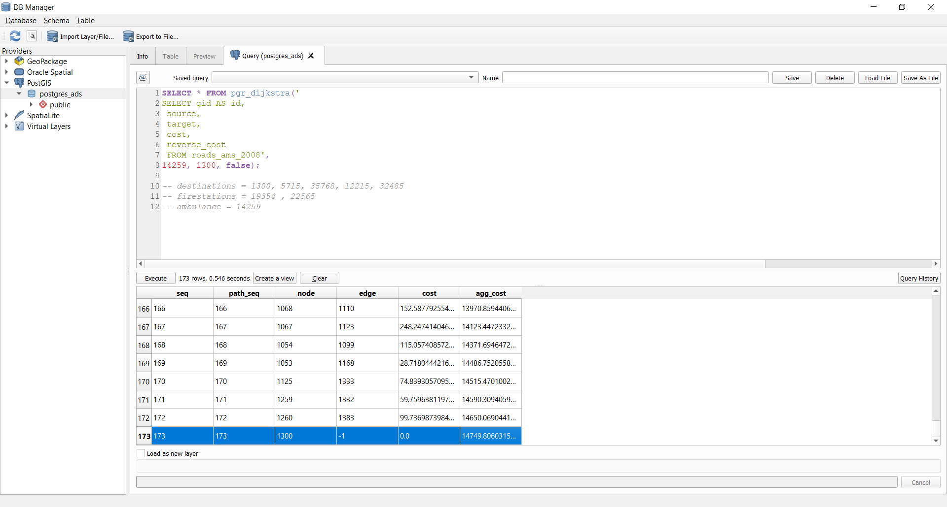

## Summary table with all destinations:

|  |  |  |  |
| --- | --- | --- | --- |
| Origin | Destination | Steps | Agg_cost(travel Distance) ** Meters |
| 14259 | 1300 | 173 | 14749.8 |
| 14259 | 5715 | 33 | 3024.47 |
| 14259 | 35768 | 158 | 12333 |
| 14259 | 12215 | 104 | 5628.16 |
| 14259 | 32485 | 192 | 16089 |

Or it can be done by adding a calculated field in each query:

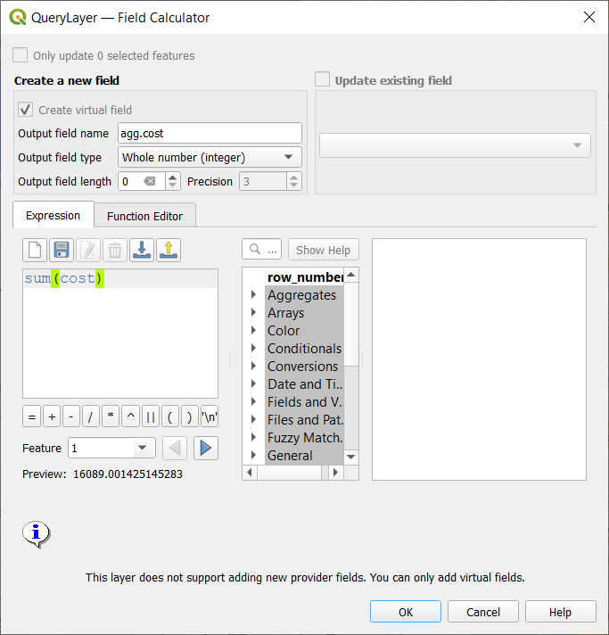

# Example of map visualization saved as image

# Appendix:

Path algorithm used:

*SELECT s.seq, s.node, s.edge, s.cost,*

*b.gid, b.geom*

*FROM*

*(*

*SELECT * FROM pgr_dijkstra('*

*SELECT gid AS id,*

*source,*

*target,*

*cost,*

*reverse_cost*

*FROM roads_ams_2008',*

*HEREYOURCODE_QUERY, 12215, false)*

*) s*

*LEFT JOIN roads_ams_2008 b*

*ON (b.gid = s.edge)*

*-- Codes of each geom used in this tutorial and assigment*

*-- destinations = 1300, 5715, 35768, 12215, 32485*

*-- firestations = 19354 , 22565*

*-- ambulance = 14259*